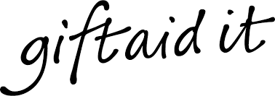

GIFT AID DECLARATION FORM

Are you a UK taxpayer?
As an academy, Chauncy School is classified as a charity for tax purposes.
Charitable donations to Chauncy School are therefore eligible for Gift Aid. By completing this form, Chauncy School will receive an additional £25 for every £100 you donate.

Please treat as Gift Aid donations:
All qualifying gifts of money made today - Amount donated today: £……………………………
in the future
(Please tick all boxes you wish to apply)

Your details:

Title: ………………… Forename(s): …………………………………………………Surname: ………………………..……………………..

Home address (including postcode): …………………………………….………………………………………………………………………

……………………………………………………………………………………………………………………………………………………………………..

……………………………………………………………………………………………………………………………………………………………………..

I confirm that I am a tax payer and have paid, or will pay, enough UK Income or Capital Gains Tax (not including Council Tax and VAT) to cover all of my charitable donations.
I would like all donations made to Chauncy School from the date of the declaration and all future donations to be Gift Aid donations until notified otherwise.
I declare that any donations in the current tax year and in the future made by me to Chauncy Schoo,l in return for which I receive no direct benefits, services our favours, shall be treated by the Charities as a Gift Aid donation.
If I cease to be a tax payer, I will notify the Charity to withdraw this declaration.

Signature: ……………………………………………………………………… Date: ………………………………………………………………….

If you pay Income Tax at the higher rate and want to receive the additional tax relief due to you, you must include all your Gift Aid donations on your Self-Assessment tax return or ask HMRC to adjust your tax code

