MARCH 2021
Return to School – A Guide for Students, Parents & Carers
Please note that this document is subject to change according to amendments in health and safety advice from Public Health England and the Department for Education. Please check www.chauncyschool.com/covid-19 for further updates.

- TESTING
We have offered all students a Lateral Flow Test prior to their return to school, starting on Thursday 4th March 2021. We have a trained testing team who will brief students in the old gym before testing them in the Hall. Students have been invited into school to be tested on the day before they are due to return to school. A timetable has been e-mailed to students and parents and is available from our website www.chauncyschool.com/covid-19 .

- PHASED RETURN TO SCHOOL
We will have a phased return to school, testing students from Thursday 4th March and students returning to face to face lessons in school from Monday 8th March 2021:

Year Group Tested on Return to school on
Year Thirteen Thursday 4th March 2021 Monday 8th March 2021
Year Twelve Thursday 4th March 2021 Monday 8th March 2021
Year Eleven Friday 5th March 2021 Monday 8th March 2021
Year Ten Monday 8th March 2021 Tuesday 9th March 2021
Year Nine Tuesday 9th March 2021 Wednesday 10th March 2021
Year Eight Wednesday 10th March 2021 Thursday 11th March 2021
Year Seven Thursday 11th March 2021 Friday 12th March 2021

- REMOTE LEARNING FOR THOSE STUDENTS NOT IN SCHOOL
Whilst we phase students back into school, we will continue to teach students who are not in school via Zoom lessons in the allocated lesson slot on the timetable.
- Resources will be put in a Classwork task in Google Classroom and posted on Edulink so students and parents have access.
- Zoom meeting details will be posted on Edulink as a separate homework, so students and parents can access log in codes quickly.

- HEALTH CHECK LIST
- Parents \ Carers should carry out the following check list daily before their child leaves home each morning. They must not send their child to school if they have:
  - A temperature over 38°C
  - A persistent dry cough
  - A lack of taste or smell
- Similarly staff will not attend school if they present any of the above symptoms.
- If any of these symptoms are present, the individual should stay at home and self-isolate until a test is arranged.

- STUDENTS WHO FEEL UNWELL
- Any student who feels feeling unwell will see a first aider.
- If a student reports being unwell with any of the symptoms of COVID-19 they will be isolated.
- The child will be placed in the area where there is adequate ventilation and social distancing can be maintained.
- Parents will be informed and asked to collect the child and book a coronavirus test.
- The child will need to self-isolate for ten days unless a negative test result is produced.

- ONE WAY SYSTEM
We have adopted a one-way system for moving around the school.
Where classrooms have an external door, this should be an exit only.
This one-way system is highlighted by green floor markers.

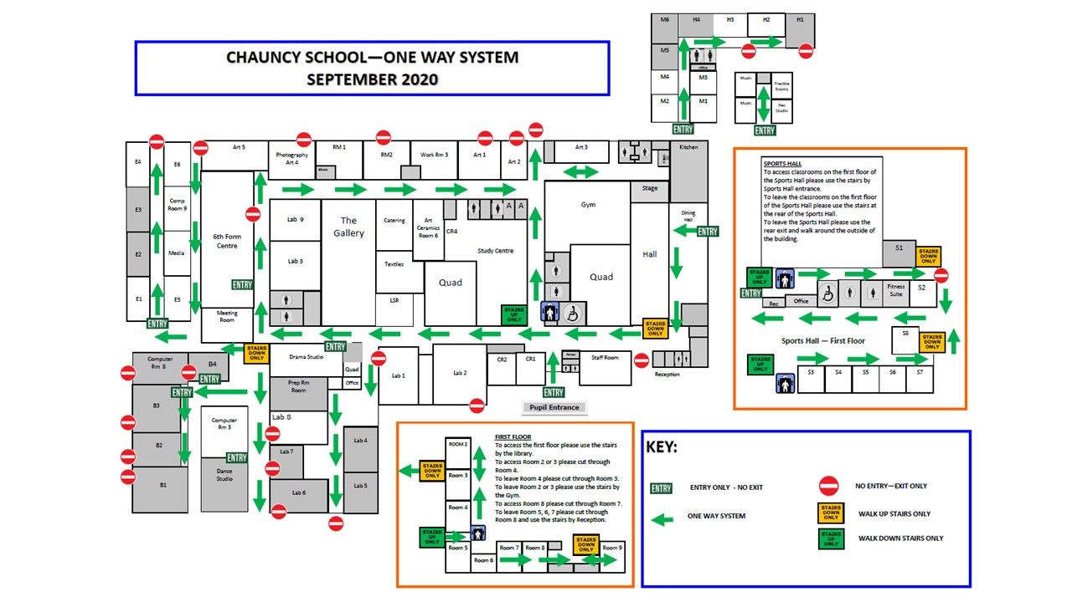

- HAND HYGIENE & RESPIRATORY HYGIENE
- Students will be taught about thorough and regular hand washing using E-Bug website resources as recommended by the DfE.
- Posters highlighting hand hygiene routines are placed around the school, near sinks and in all toilets.
- Students will be taught about respiratory hygiene using the ‘Catch It, Bin, It, Kill It’ campaign publicised by Public Health England.
- Posters reminding students about the ‘Catch It, Bin, It, Kill It’ campaign have been placed around the school and will be displayed in every classroom.
- A box of tissues and anti-bacterial hand sanitiser will be placed in every sanitisation station in every room in the school. These stations will be checked and topped up daily by cleaning staff.

- ENHANCED CLEANING
- The school will employ additional cleaners to work throughout the school day.
- Cleaners will sanitise rooms such as ICT, technology and PE Changing Rooms and will also do a general clean around school during the day and will target bannisters, door handles, toilets.
- There will be a sanitisation station in each classroom, this will include anti-bacterial hand gel, antibacterial spray, a cleaning cloth that will be replaced daily and a box of tissues.
- Teachers will clean their own classroom, targeting desks and surfaces between lessons. Teachers who have known vulnerabilities will not be asked to clean their rooms and cleaning staff will cover this duty.
- Any equipment that is shared in lessons such as science and technology equipment will be removed and cleaned before it is used by another student.
- PE equipment will be cleaned regularly throughout the session by the teacher if there is student contact e.g. balls and racquets etc.

9. THE SCHOOL DAY
- 8.15am Clubs will run for Year Seven to help stagger the start of the school day. Computer rooms will be cleaned prior to Lesson One.
- No morning registration. Period One will start promptly at 8.50am.
- The AM Register will be taken by the Period One class teacher before 9.00am.
- The PM registration will take place in a tutor session at the end of the day at 3.25pm.
- Travel time will be increased to 10 minutes to allow students to use the one way system effectively.

8.15am YEAR SEVEN CATCHUP CLUBS
8.50am PERIOD ONE – 60 mins (AM register taken during P1)
9.50am Travel Time – 10 mins
10.00am PERIOD TWO – 60mins
11.00pm Break – 20 mins
11.20am PERIOD THREE – 60 mins
12.20pm Travel Time – 10 mins
12.30pm PERIOD FOUR – 60 mins
1.30pm Lunch – 45 mins
2.15pm PERIOD FIVE – 60 mins
3.15pm Travel Time – 10 mins
3.25pm Tutorial – 10 minutes (PM register taken in PM Tutorial)
3.35pm School finishes

- STRUCTURE OF LESSONS
- We will not ask students to line up outside the classroom. Entry straight into the room is required to facilitate the one-way system.
- All students must use hand gel upon entry to the room in all lessons throughout the day.
- Desks will face the front where possible. Students will not be sat facing each other.
- Lessons will be planned carefully so that sharing of resources is minimal and that regular cleaning of shared items takes place.
- Teachers will wipe desktops at the end of each session. Anti-bacterial spray and cloth wipes are available in the sanitisation station provided in each classroom. Cloth wipes will be removed and replaced at the end of each day.

- TRANSPORT
- Students who arrive via school bus must wear a face mask whilst they travel. Students must also keep a social distance or sit in their year group bubble where possible when on the school bus.
- We encourage students and staff to walk, cycle and scoot to school if they can.
- Students should not walk in large groups to school and should not congregate at shops or parks on the way to school. A two meter social distance is encouraged.
- Parents should not enter school premises or wait at the school gates for their child to finish school.

- DINING HALL AND FOOD
- The Dining Hall will serve ‘take away’ food at break time and lunchtime.
- Year Groups will be given a time on a rota to attend the Dining Hall and will queue in their year group socially distant from other year groups.

- HANDLING CASH
- We are now cashless, the finance office will not accept cash payments.
- All payments should be made via WisePay.
- Support is available from the Finance Office to assist parents in accessing WisePay please e-mail: accounts@chauncy.org.uk

- SCHOOL RECEPTION
- We discourage parents from visiting the school.
- Parents picking up or dropping off items such as PE kit, cooking ingredients or medicine will have to use the hatch in the Reception Foyer area.
- Visitors will sign in at the Reception Foyer area and wait on the sofa until collected by the relevant member of staff.

- PARENTAL ENQUIRIES
- Any parent enquiries to be via the school email address in the first instance.
- Staff will reply to parental e-mails as soon as they are able.

- BEHAVIOUR EXPECTATIONS
- Expectations of behaviour remain high.
- Students who cannot follow the safety measures put in place may face fixed term exclusion.
- After school detentions will be encouraged rather than lunch time detentions as we do not wish to mix students of different years in rooms during the lunch or break time. We wish to have students outside as much as possible during break and lunch.
- Students placed in detention should be in their own year group in a room or kept at a strict two meter social distance if not in the same year group.

- SEND
- Due to rules on proximity Teaching Assistants cannot work effectively 1:1 in the classroom.
- Teaching Assistants may withdraw students from classes and work in Learning Support Room or SEN Room 2, maintaining social distance where possible and using face masks and visors, where required.

- ENHANCED STAFF DUTIES
- Two duty rotas will be employed - a dry day rota and a wet day rota.
- Whilst the weather is fine, we will ask all students to go outside. Staff duties will be mainly on access doors and supervising fields and playgrounds.
- When the weather is inclement, we have organised the school into Year Group zones. Staff duties will be mainly on corridors and in areas where we have allowed students to sit in their year group.
- During wet breaks and lunched staff are asked to open and supervise in their classroom.
- An e-mail will advise staff of which duty rota is to be employed before break or lunchtime.

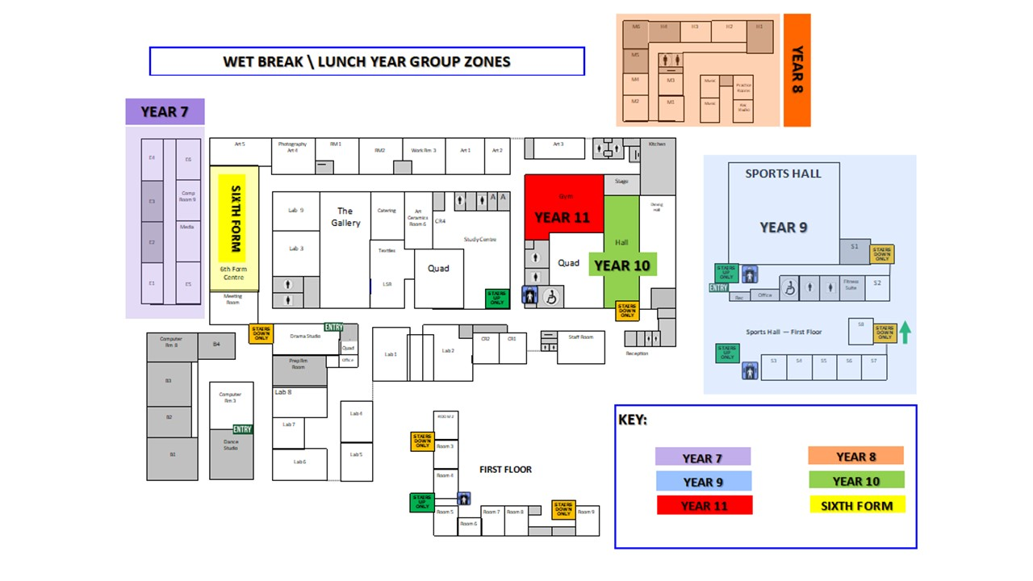
- ADDITIONAL CURRICULUM MODIFICATIONS
- We aim to teach a high quality, broad and balanced curriculum without reducing subjects at KS3, KS4 or KS4.

- SEATING PLANS
- To assist the track and trace process in the event of an incidence of COVID-19 we need all staff to keep an accurate seating plan for all lessons. This will allow us to identify which students have been in close proximity to a child tested positive for COVID-19. Seating Plans will be stored on Edulink.

- FACE COVERINGS
We ask that all students and staff wear a face covering when they are inside the school buildings and social distancing cannot be maintained. This will mean wearing face covering when:
- In Classrooms
- On the Corridors
- Using the Toilet Facilities
- Visiting Offices
- Entering the Dining Hall
- Travelling on Public Transport
Students will not have to wear a facemask unless they want to when:
- Outside on the playground or backfields
- Travelling to and from school by foot, bike, scooter or private car
The school will not be providing face coverings for students and staff so it is important that face coverings are packed with the other essential items daily.
We do understand that some students are exempt from wearing a face covering.
The latest advice on face coverings can be found on the gov.uk website here:
https://assets.publishing.service.gov.uk/government/uploads/system/uploads/attachment_data/file/965446/Face_coverings_in_education_-_March_2021.pdf
- VENTILATION
We will be making sure that classrooms are well ventilated.
This will mean keeping windows and doors open or using air conditioning, where available.
It may be advisable for students to wear additional layers such as a plain black V-neck jumper during the Spring Term.

- UNIFORM
The Department for Education has encouraged all schools to return to their usual uniform policies.
Uniforms do not need to be cleaned any more often than usual, nor do they need to be cleaned using methods which are different from normal.

- DESIGNATED TOILETS FOR BREAK TIME AND LUNCHTIME
All of our toilets will be cleaned regularly and thoroughly throughout the day.
During lesson time, students should use the nearest toilet to their classroom and maintain a social distance of 2 metres from all other students.

At break time and lunchtime when there is a greater demand for toilet facilities, we ask that students use the toilets assigned to their Year Group Area as follows:
- Year Seven Art Corridor Toilets & Dance Studio Toilets
- Year Eight Art Corridor Toilets & Maths Block Toilets
- Year Nine Sports Hall Toilets
- Year Ten Library Corridor Toilets
- Year Eleven Library Corridor Toilets
- Year Twelve Sixth Form Toilets
- Year Thirteen Sixth Form Toilets

We ask that students maintain a 2 metre social distance whilst queuing for the toilets and that they wash their hands thoroughly for the recommended time of 20 seconds, using the anti-bacterial soap provided.

- MARKING
The DfE guidance for full opening: schools sets out the following guidance for school-based equipment and resources:

“Classroom based resources, such as books and games, can be used and shared within the bubble; these should be cleaned regularly, along with all frequently touched surfaces. Resources that are shared between classes or bubbles, such as sports, art and science equipment should be cleaned frequently and meticulously and always between bubbles, or rotated to allow them to be left unused and out of reach for a period of 48 hours (72 hours for plastics) between use by different bubbles.”

Whilst there is no specific guidance on collecting books and paper to mark we will consider the following:
- Request electronic submission of work where possible.
- As far as reasonably possible teachers should not take paper based work home to mark.
- Students can do their work to be marked on a single sheet of paper which they themselves stick in their books once marked.
- When considering or needing to use paper books, documents, booklets, folders, and textbooks, consider following Covid-19 guidelines for other related situations, such as those set out in bookshops.
- Having a crate or tray labelled with the day/date, for pupils to deposit work in, which they then leave for the appropriate number of hours.
- The CILIP (Library and information association) guidance for textbooks is 72 hours’ quarantine for plastic covers, and 24 hours’ quarantine for cardboard and paper-backed books (see further details below).
- GUIDANCE ON QUARANTINE PERIODS FOR LIBRARY MATERIALS
Please note guidance from the COVID-19 Guidance Cell of Public Health England’s National Infection Service, as advised to CILIP and DCMS:
- The risk from books covered in a plastic cover handled by someone who is a possible COVID-19 case is negligible after 72 hours.
- The risk from books with a cardboard/paper cover is negligible after 24 hours.
- Chauncy School will be leaving used library books in ‘quarantine’ for 72 hours before handling.

