Return to School – A Guide for Parents \ Carers
Please note that this document is subject to change according to amendments in health and safety advice from Public Health England and the Department for Education.

- PHASED RETURN TO SCHOOL
We will have a phased return to school from September 1st 2020:

Monday 31st August 2020 – Bank Holiday
Tuesday 1st September 2020 – Staff INSET Day 1
Wednesday 2nd September 2020 – Staff INSET Day 2
Thursday 3rd September 2020 - Year 7 and Year 12 only in school

Friday 4th September 2020
- Years 7, 10, 11, 12, 13 only
- No Year 8 or 9 students - remote learning

Week commencing Monday 7th September 2020
- Years 7, 10, 11, 12, 13 only
- No Year 8 or 9 students – remote learning all week

Week commencing Monday 14th September 2020
- Year 7, 8, 9, 11 & 13 only
- No Year 10 & 12 students – remote learning all week

- REMOTE LEARNING FOR THOSE STUDENTS NOT IN SCHOOL
- We will still teach students who are not in school via Zoom lessons in the allocated lesson slot on the timetable.
- Face to Face Zoom lessons are to be approximately 30 mins with self-study activities set.
- Resources will be put in a Classwork task in Google Classroom and posted on Edulink so students and parents have access to the task description.
- Zoom meeting details will be posted on Edulink as a separate homework, so students and parents can access log in codes quickly.

- HEALTH CHECK LIST
- Parents \ Carers should carry out the following check list daily before their child leaves home each morning. They must not send their child to school if they have:
  - A temperature over 38°C
  - A persistent dry cough
  - A lack of taste or smell
- Similarly staff will not attend school if they present any of the above symptoms.
- If any of these symptoms are present, the individual should stay at home and self-isolate until a test is arranged.

- STUDENTS WHO FEEL UNWELL
- Any student who feels feeling unwell will see a first aider.
- If a student reports being unwell with any of the symptoms of COVID-19 they will be isolated.
- The child will be placed in the School Hall where there is adequate ventilation and social distancing can be maintained.
- The first ad staff will collect a PPE pack from Reception which will include a mask, a visor, latex gloves and an apron.
- Parents will be informed and asked to collect the child and book a coronavirus test.
- The child will need to self-isolate for ten days unless a negative test result is produced.
- The school will need to see a copy of the test result before the child can return to school.

- ONE WAY SYSTEM
We have adopted a one-way system for moving around the school. Please see the map attached.
Where classrooms have an external door, this should be an exit only.
From 3rd September 2020 this one-way system will be highlighted by green floor markers.

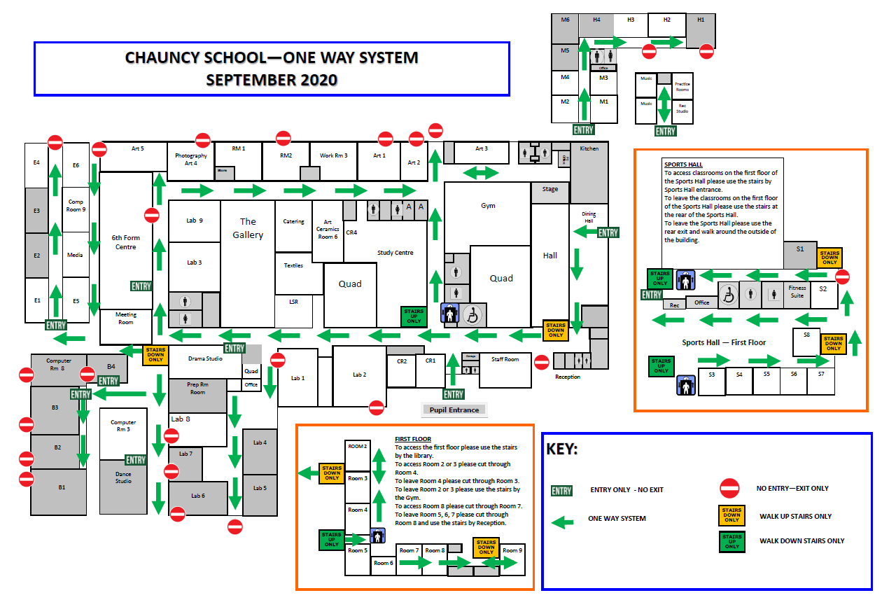

- HAND HYGIENE & RESPIRATORY HYGIENE
- Students will be taught about thorough and regular hand washing using E-Bug website resources as recommended by the DfE.
- Posters highlighting hand hygiene routines are placed around the school, near sinks and in all toilets.
- Students will be taught about respiratory hygiene using the ‘Catch It, Bin, It, Kill It’ campaign publicised by Public Health England.
- Posters reminding students about the ‘Catch It, Bin, It, Kill It’ campaign have been placed around the school and will be displayed in every classroom.
- A box of tissues and anti-bacterial hand sanitiser will be placed in every sanitisation station in every room in the school. These stations will be checked and topped up daily by cleaning staff.

- ENHANCED CLEANING
- The school will employ additional cleaners to work throughout the school day.
- Cleaners will target key rooms such as computer rooms where desks, chairs, keyboards, mice, door handles and light switches will be thoroughly cleaned.
- Cleaners will also do a general clean around school during the day and will target bannisters, door handles, toilets, changing room benches and hooks.
- There will be a sanitisation station in each classroom, this will include anti-bacterial hand gel, antibacterial spray, a cleaning cloth that will be replaced daily and a box of tissues.
- Teachers will clean their own classroom, targeting desks and chairs in between lessons. Teachers who have known vulnerabilities will not be asked to clean their rooms and cleaning staff will cover this duty.
- Any equipment that is shared in lessons such as science and technology equipment will be removed and cleaned before it is used by another student.
- PE equipment will be cleaned regularly throughout the session by the teacher if there is student contact e.g. balls and racquets etc.

9. THE SCHOOL DAY
- 8.15am ‘Catch Up’ Clubs will run for Year Seven from September to help stagger the start of the school day. Computer rooms will be cleaned prior to Lesson One.
- No morning registration. Period One will start promptly at 8.50am.
- The AM Register will be taken by the Period One class teacher before 9.00am.
- The PM registration will take place in a tutor session at the end of the day at 3.25pm.
- Travel time will be increased to 10 minutes to allow students to use the one way system effectively.

8.15am YEAR SEVEN CATCHUP CLUBS
8.50am PERIOD ONE – 60 mins (AM register taken during P1)
9.50am Travel Time – 10 mins
10.00am PERIOD TWO – 60mins
11.00pm Break – 20 mins
11.20am PERIOD THREE – 60 mins
12.20pm Travel Time – 10 mins
12.30pm PERIOD FOUR – 60 mins
1.30pm Lunch – 45 mins
2.15pm PERIOD FIVE – 60 mins
3.15pm Travel Time – 10 mins
3.25pm Tutorial – 10 minutes (PM register taken in PM Tutorial)
3.35pm School finishes
- STRUCTURE OF LESSONS
- We will not ask students to line up outside the classroom. Entry straight into the room is required to facilitate the one-way system.
- All students must use hand gel upon entry to the room in all lessons throughout the day.
- Desks will all face the front. Students will not be sat facing each other.
- Lessons will be planned carefully so that sharing of resources is minimal and that regular cleaning of shared items takes place.
- Teachers will wipe desktops and chairs at the end of each session. Anti-bacterial spray and cloth wipes are available in the sanitisation station provided in each classroom. Cloth wipes will be removed and replaced at the end of each day.

- TRANSPORT
- Students who arrive via school bus must wear a face mask whilst they travel. Students must also keep a social distance when on the school bus.
- We encourage students and staff to walk, cycle and scoot to school if they can.
- Students should not walk in large groups to school and should not congregate at shops or parks on the way to school. A two meter social distance is encouraged.
- Parents should not enter school premises or wait at the school gates for their child to finish school.

- DINING HALL AND FOOD
- The Dining Hall will be closed at break time and lunchtime.
- We will not be serving food initially.
- A packed lunch will be provided for students entitled to Free School Meals. This will consist of a sandwich, a yoghurt, a piece of fruit and a bottle of water.

- HANDLING CASH
- We are now cashless, the finance office will not accept cash payments.
- All payments should be made via WisePay.
- Support is available from the Finance Office to assist parents in accessing WisePay please e-mail: accounts@chauncy.org.uk

- SCHOOL RECEPTION
- We discourage parents from visiting the school.
- Parents picking up or dropping off items such as PE kit, cooking ingredients or medicine will have to use the hatch in the Reception Foyer area.
- Visitors will sign in at the Reception Foyer area and wait on the sofa until collected by the relevant member of staff.

- PARENTAL ENQUIRIES
- Any parent enquiries to be via the school email address in the first instance.
- Staff will reply to parental e-mails as soon as they are able.
- BEHAVIOUR EXPECTATIONS
- Expectations of behaviour remain high.
- Students who cannot follow the safety measures put in place will face fixed term exclusion.
- After school detentions will be encouraged rather than lunch time detentions as we do not wish to mix students of different years in rooms during the lunch or break time. We wish to have students outside as much as possible during break and lunch.
- Students placed in detention should be in their own year group in a room or kept at a strict two meter social distance if not in the same year group.

- SEND
- Due to rules on proximity Teaching Assistants cannot work effectively in the classroom.
- Teaching Assistants will withdraw students from classes and work in LSR or SEN Room 2, maintaining social distance where possible and using face masks and visors, where required.

- ENHANCED STAFF DUTIES
- Two duty rotas will be employed - a dry day rota and a wet day rota.
- Whilst the weather is fine, we will ask all students to go outside. Staff duties will be mainly on access doors and supervising fields and playgrounds.
- When the weather is inclement, we have organised the school into Year Group zones. Staff duties will be mainly on corridors and in areas where we have allowed students to sit in their year group.
- During wet breaks and lunched staff are asked to open and supervise in their classroom.
- An e-mail will advise staff of which duty rota is to be employed before break or lunchtime.

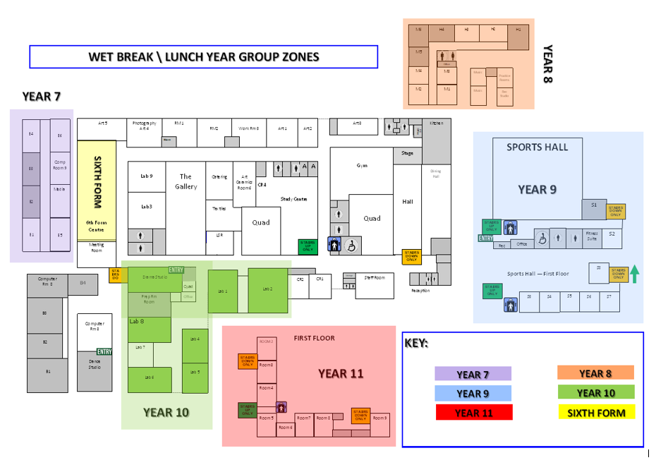
- ADDITIONAL CURRICULUM MODIFICATIONS
- We aim to teach a high quality, broad and balanced curriculum without reducing subjects at KS3, KS4 or KS4.
- We await further clarification from the DfE on what activities are permitted where proximity or group work is usual, however some guidance is available for PE and Music:

- PE – from latest DfE guidance 07.08.2020
  - Schools have the flexibility to decide how physical education, sport and physical activity will be provided whilst following the measures in their system of controls. Pupils should be kept in consistent groups, sports equipment thoroughly cleaned between each use by different individual groups, and contact sports avoided.
  - Outdoor sports should be prioritised where possible, and large indoor spaces used where it is not, maximising distancing between pupils and paying scrupulous attention to cleaning and hygiene. This is particularly important in a sports setting because of the way in which people breathe during exercise. External facilities can also be used in line with government guidance for the use of, and travel to and from, those facilities.
  - Students do not have to come to school in PE kit, we will separate PE changing rooms by Year group and will clean the changing rooms in between use.
  - No extra-curricular activities initially, this is to include sporting fixtures, drama clubs etc. to reduce mixing and proximity.

- Music – from latest DfE guidance 07.08.2020
  - Schools should note that there may be an additional risk of infection in environments where you or others are singing, chanting, playing wind or brass instruments or shouting. This applies even if individuals are at a distance. Schools should consider how to reduce the risk, particularly when pupils are playing instruments or singing in small groups such as in music lessons by, for example, physical distancing and playing outside wherever possible, limiting group sizes to no more than 15, positioning pupils back-to-back or side-to-side, avoiding sharing of instruments, and ensuring good ventilation. Singing, wind and brass playing should not take place in larger groups such as school choirs and ensembles, or school assemblies. Further detailed DfE guidance will be published shortly.

- Other Departments
  - Each Department should look at the DfE guidance document before planning activities:
https://www.gov.uk/government/publications/actions-for-schools-during-the-coronavirus-outbreak/guidance-for-full-opening-schools

- MARKING
- At present staff will use e-mail, Google Classroom and other online learning systems to assess student progress. If paper-based work must be handled e.g. art work or coursework, it must be left untouched in a box for 72 hours before being handled by staff.

