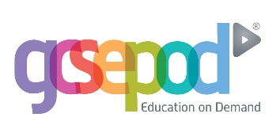
Dear Parent/Guardian,
GCSEPod is now available! Chauncy School has invested in GCSEPod, the award-winning digital content and revision provider used by over 1,000 schools worldwide.
GCSEPod provides over 6,000 3-5 minute bursts of visual learning via their short videos called ‘Pods’. Each Pod is exam board specific, so you can be reassured your child is accessing the correct information. GCSEPod makes learning and revision much more manageable as the Pods contain all the right facts, quotes, keywords, dates and annotated diagrams that your child needs for GCSE success and they are neatly organised into topic or exam playlists.
One of the remarkable things about GCSEPod is the ability to download the content to your child’s mobile device so it’s like they are carrying text books in their pockets without the need for internet. You can download the GCSEPod app from the App Store (Apple and Android are supported).
In addition, your child’s teachers may set homework on GCSEPod. After completing homework, your child will receive a personalised online “Boost Playlist” containing Pods relevant to their identified areas of weakness. Please ensure your child reviews these playlists regularly as this will accelerate their progress.
Once your child has activated their account they can browse the Pod library and create their own playlists – just as they would when they’re listening to music. We recommend that you discuss GCSEPod with your son or daughter to ensure that they have successfully activated their accounts and encourage them to make use of this service throughout their GCSEs.

For more ways you can help support your child using GCSEPod, please visit www.gcsepod.com/parents where you’ll find lots more information and resources.
Your child has already been registered with GCSEPod and if they’ve not yet activated their account they will need to follow the instructions below. If your child has already activated but can’t remember their username and password, please ask them to contact a member of staff.
- Go to www.gcsepod.com and click “Login” in the top right-hand corner
- Click “New here? Get started.”
- Select “Student”
- Enter your child’s name, date of birth and confirm the school name.
- Create a username, password, and a password hint to help you remember the password.
If you have any questions regarding GCSEPod please contact Mr O’Shea who is GCSEPod Lead for the school.
Yours sincerely,
Matthew O’Shea

