Year 8
End of year test revision.

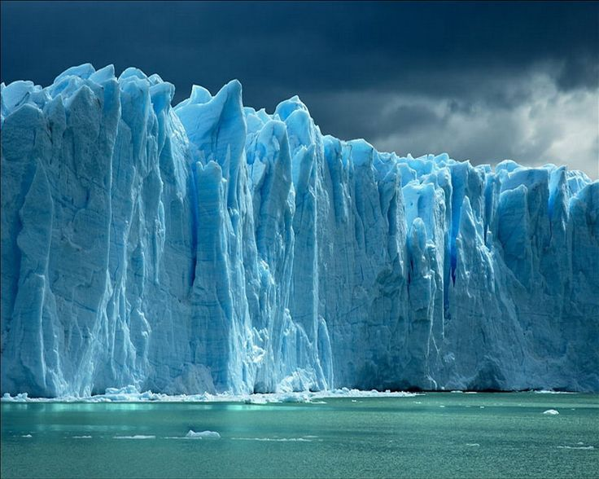
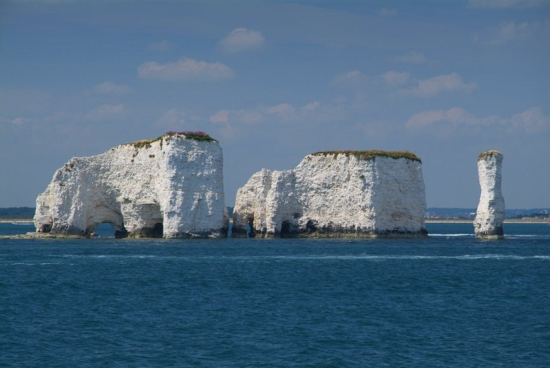
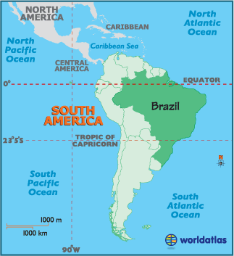

What topics have you studies this year in year 8?

Making a start……
Put each of the topics you have studied around each leg. Around this put everything you can remember about these topics.
Year 8

Topic focused revision:
Crime
List all of the different crimes you can think of.
………………………………………………….
………………………………………………….
………………………………………………….
………………………………………………….
………………………………………………….
………………………………………………….
………………………………………………….
………………………………………………….

What is the overall definition of crime?
………………………………………………………………………………………………………………………………………………………………………………………………………………………………………………………………………………………………………………………………………………………………………………………………………………………………………………………………………

Study the map below:

Describe the pattern of this type of crime.
………………………………………………………………………………………………………………………………………………………………………………………………………………………………………………………………………………………………………………………………………………………………………………………………………………………………………………………………………
Give reasons for this.
………………………………………………………………………………………………………………………………………………………………………………………………………………………………………………………………………………………………………………………………………………………………………………………………………………………………………………………………………
………………………………………………………………………………………………………………………………………………………………………………………………………………………………………………………………………………………………………………………………………………………………………………………………………………………………………………………………………
What is a victim?
Is this more than one person?
………………………………………………………………………………………………………………………………………………………………………………………………………………………………………………………………………………………………………………………………………………………………………………………………………………………………………………………………………
………………………………………………………………………………………………………………………………………………………………………………………………………………………………………………………………………………………………………………………………………………………………………………………………………………………………………………………………………
Use the space below to develop a post on how you could reduce crime.

For an international crime you have studied:
Give details of this (include facts if you can)
State why it is happening.
Give ways to solve this.
………………………………………………………………………………………………………………………………………………………………………………………………………………………………………………………………………………………………………………………………………………………………………………………………………………………………………………………………………
………………………………………………………………………………………………………………………………………………………………………………………………………………………………………………………………………………………………………………………………………………………………………………………………………………………………………………………………………
………………………………………………………………………………………………………………………………………………………………………………………………………………………………………………………………………………………………………………………………………………………………………………………………………………………………………………………………………
………………………………………………………………………………………………………………………………………………………………………………………………………………………………………………………………………………………………………………………………………………………………………………………………………………………………………………………………………
………………………………………………………………………………………………………………………………………………………………………………………………………………………………………………………………………………………………………………………………………………………………………………………………………………………………………………………………………
………………………………………………………………………………………………………………………………………………………………………………………………………………………………………………………………………………………………………………………………………………………………………………………………………………………………………………………………………

Glaciers
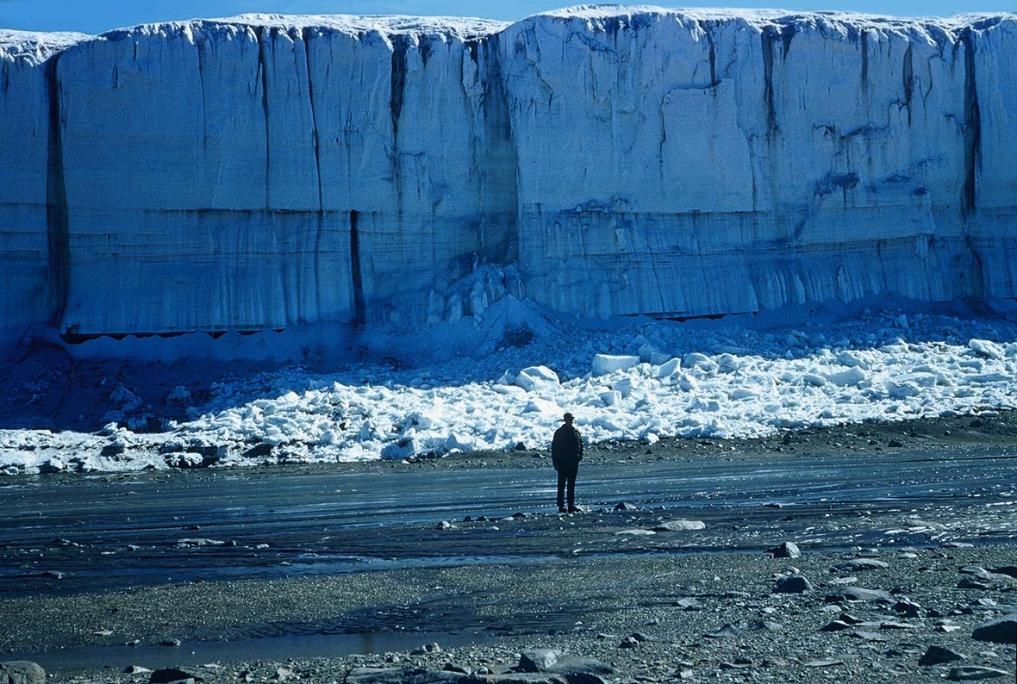

Number the list in order for how a glacier is formed:
This changes the snow into ice
In cold areas snow falls
The weight of this then compresses the snow
Layer upon layer of snow fall and begin to build up.
As this gets thicker and heavier the ice eventually starts to flow (because of the pressure and its own weight).

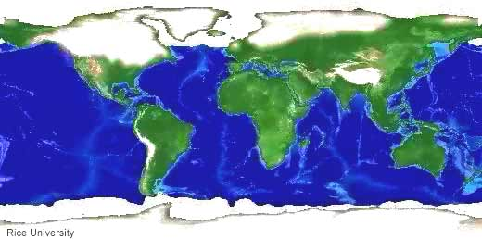
Look at the map

Label the map with information of where the glaciers are.
Why are the glaciers located here?
………………………………………………………………………………………………………………………………………………………………………………………………………………………………………………………………………………………………………………………………………………………………………………………………………………………………………………………………………
………………………………………………………………………………………………………………………………………………………………………………………………………………………………………………………………………………………………………………………………………………………………………………………………………………………………………………………………………

The processes:
Fill in the table with as much detail as possible.
Erosion | Transportation | Deposition

For 2 glacial land forms of your choice create 2 comic strips for how these are formed.

How are our glaciers changing and why?
………………………………………………………………………………………………………………………………………………………………………………………………………………………………………………………………………………………………………………………………………………………………………………………………………………………………………………………………………
………………………………………………………………………………………………………………………………………………………………………………………………………………………………………………………………………………………………………………………………………………………………………………………………………………………………………………………………………
Brazil
The rainforest:
Draw and describe the 4 layers of the rainforest:

Draw and label an animal and how it has adapted to the rainforest:

With the information below draw a climate graph for Brazil:
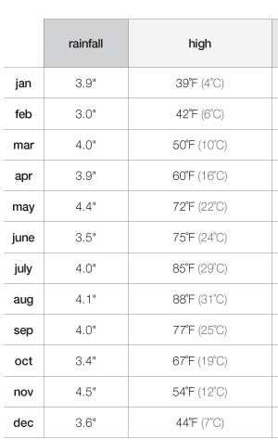

You will need graph paper for this.
Once complete answer the following questions:
- Describe the climate graph.
- Give reasons behind the climate shown.
What is sustainability?
Create 10 rules for how we can manage our rainforest sustainably.
1.

2.

3.

4.

5.

6.

7.

8.

9.

10

What is the point of doing this?

What does this say about Rio in Brazil:
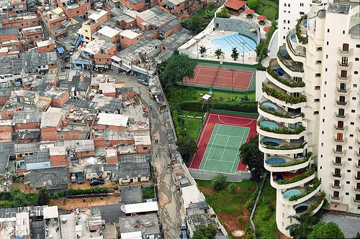

What problems could this bring?
How could be manage this?

Coasts
Look at the photo below, list all of the things a coastline could be used for.
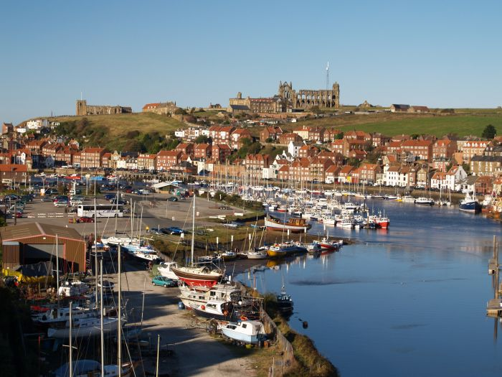
………………………………………………………………………………………………………………………………………………………………………………………………………………………………………………………………………………………………………………………………………………………………………………………………………………………………………………………………………
………………………………………………………………………………………………………………………………………………………………………………………………………………………………………………………………………………………………………………………………………………………………………………………………………………………………………………………………………
In the boxes below draw and label the 2 different waves:
Constructive | Destructive
The different processes
Erosion | Transportation | Deposition

Erosional feature or deposition.
Categorise the features below:
Spit stack stump bar cave arch beach
Erosion | Deposition

Discuss the formation of a beach
………………………………………………………………………………………………………………………………………………………………………………………………………………………………………………………………………………………………………………………………………………………………………………………………………………………………………………………………………
………………………………………………………………………………………………………………………………………………………………………………………………………………………………………………………………………………………………………………………………………………………………………………………………………………………………………………………………………
Discuss the formation of a cave arch stack and stump
………………………………………………………………………………………………………………………………………………………………………………………………………………………………………………………………………………………………………………………………………………………………………………………………………………………………………………………………………
………………………………………………………………………………………………………………………………………………………………………………………………………………………………………………………………………………………………………………………………………………………………………………………………………………………………………………………………………
………………………………………………………………………………………………………………………………………………………………………………………………………………………………………………………………………………………………………………………………………………………………………………………………………………………………………………………………………
………………………………………………………………………………………………………………………………………………………………………………………………………………………………………………………………………………………………………………………………………………………………………………………………………………………………………………………………………

Fill out the following table for as many sea defences as you can
Name | Picture | Advantage | disadvantage

Why is it so important to protect our coastline?
Which of these is the most sustainable?

Development
What is the definition of development?
………………………………………………………………………………………………………………………………………………………………………………………………………………………………………………………………………………………………………………………………………………………………………………………………………………………………………………………………………
Create a spider diagram from the different economic development indicators:

Economic development indicators

Pick 2 of the above and explain how they show development.
………………………………………………………………………………………………………………………………………………………………………………………………………………………………………………………………………………………………………………………………………………………………………………………………………………………………………………………………………
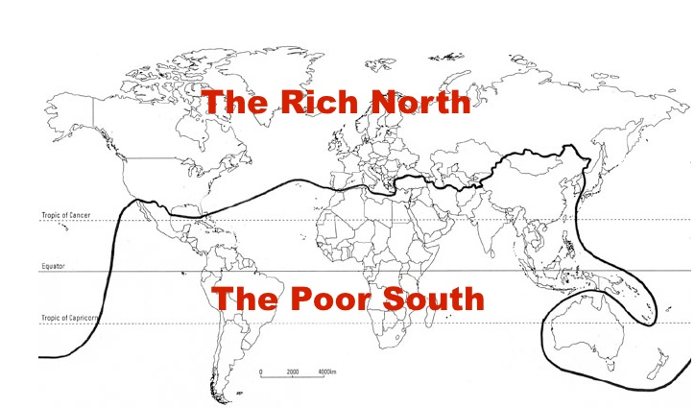
………………………………………………………………………………………………………………………………………………………………………………………………………………………………………………………………………………………………………………………………………………………………………………………………………………………………………………………………………

Study the image below:

What is this?
………………………………………………………………………………………………………………………………………………………………………………………………………………………………………………………………………………………………………………………………………………………………………………………………………………………………………………………………………
What are the advantages and disadvantages?
………………………………………………………………………………………………………………………………………………………………………………………………………………………………………………………………………………………………………………………………………………………………………………………………………………………………………………………………………

Extra space from revision.

