Centre ID: chauncyschool
Username: School Login
Password: chauncy

Year 8 End of Year Assessment Targeted Revision

- Click MathsWatch GCSE New 2015 Specs
- Search for the clip number or clip in the search bar and click go!

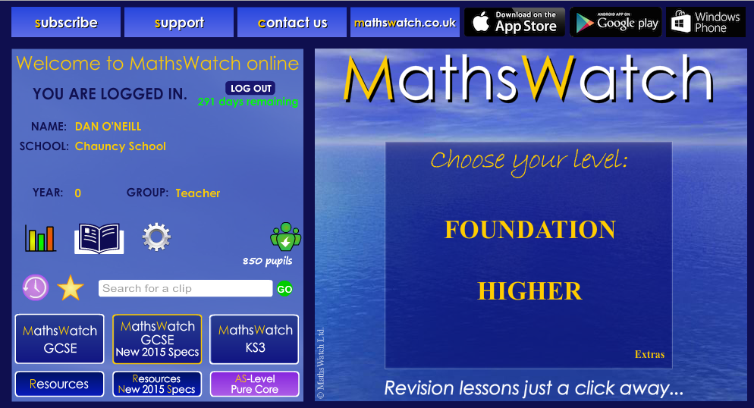

Paper A Level 3-5

Topic |  | MathsWatch
3-D Shapes | Properties of Solids | Clip 43
Reading off Diagrams/Graphs | Tally Charts and Bar Charts | Clip 15
 | Scatter Diagrams | Clip 129
Sequences | Generating a Sequence – Term to term rule | Clip 37
 | Generating a Sequence from position to term rule | Clip 102
 | Finding the nth Term | Clip 103
Fractions | Introduction to Fractions | Clip 24
 | Equivalent Fractions | Clip 25
 | Simplifying Fractions | Clip 26
 | Comparing fractions | Clip 70
 | Adding and Subtracting Fractions | Clip 71a
 | Adding and Subtracting Fractions | Clip 71b
 | Finding a Fraction of an Amount | Clip 72
 | Multiplying Fractions | Clip 73
 | Dividing Fractions | Clip 74
 | Decimals and Fractions | Clip 76
 | Fractions, Percentages, Decimals | Clip 84
Solving Equations | Solve Equations | Clip 135a
 | Solve Equations | Clip 135b
 | Forming Formulae and Equations | Clip 137

Paper B Level 5-7
Topic |  | MathsWatch
Angles | Names of Angles | Clip 13
 | Angles on a Line and at a Point | Clip 45
 | Angles and Paqrallel Lines | Clip 120
 | Angles in a Triangle | Clip 121
 | Properties of Special Triangles | Clip 122
Solving Equations | Solve Equations | Clip 135a
 | Solve Equations | Clip 135b
 | Forming Formulae and Equations | Clip 137
Reading off Diagrams/Graphs | Tally Charts and Bar Charts | Clip 15
 | Scatter Diagrams | Clip 129
Area/Volume | Area of a Rectangle | Clip 53
 | Area of a Triangle | Clip 54
 | Area of a parallelogram | Clip 55
 | Area of a Trapezium | Clip 56
 | Surface Area of a Prism | Clip 114a
 | Surface Area of a Prism | Clip 114b
 | Area of a Circles | Clip 117
 | Volume of a Cuboid | Clip 115
 | Volume of a Prism | Clip 119
Ratio | Using Ratio for Recipe | Clip 39
 | Sharing using Ratio | Clip 106
 | Ratios, Fractions and Graphs | Clip 107

Paper C Level 6-8
Topic |  | MathsWatch
Pythagoras/trigonometry | Pythagoras Theorem | Clip 150a
 | Pythagoras Theorem | Clip 150b
 | Pythagoras Theorem | Clip 150c
 | Pythagoras Theorem in 3D | Clip 217
 | Trigonometry | Clip 168
 | Trigonometry in 3D | Clip 218
Simultaneous Equations | Simultaneous Equations | Clip 140
 | Simultaneous Equations | Clip 162
 | Simultaneous Equations with a quadratic | Clip 211
Solving Equations | Solve Equations | Clip 135a
 | Solve Equations | Clip 135b
 | Forming Formulae and Equations | Clip 137
Similar Shapes | Similar Shapes | Clip 144
 | Similarity – Area/Volume | Clip 200
Single/Double Brackets | Expanding Brackets | Clip 93
 | Expanding and Simplifying | Clip 134a
 | Expanding and Simplifying | Clip 134b
 | Simple Factorisation | Clip 94
 | The Difference of Two Squares | Clip 158
 | Factorising Hard Quadratics | Clip 192

