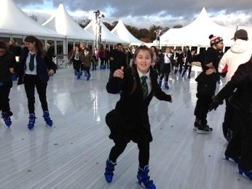
Thursday, 15 October 2015

Dear Parent \ Carer

Once again we have negotiated a deal with Van Hage so that all of our students can enjoy a subsidised skating session or only £6.00 on Tuesday 1st December 2015.

Each year group has been allocated a time slot and will travel to and from Van Hague by Golden Boy coaches.
- Year Seven 11.00am – 12.00pm
- Year Eight 12.00pm – 1.00pm
- Year Nine 1.00pm – 2.00pm
- Year Ten 2.00pm – 3.00pm
- Year Eleven 3.00pm – 4.00pm (students will be dismissed from Van Hague unless they request return transport)
- Sixth Form 7.00pm – 8.00pm (students make their own way there and back)

Break and lunch arrangements will be modified accordingly and we have made the day a non-uniform day to make it easier for the students to skate. When your child isn’t skating or travelling, normal lessons will take place. Due to the complexity of organising such an activity day, students who cannot or do not wish to participate will be given appropriate work to do and will be supervised at Chauncy whilst their year group attends the session.

Van Hage will be making these sessions exclusive to Chauncy School. Therefore we will need to confirm numbers quickly to secure our booking. If your son or daughter wishes to participate in this excellent trip, please complete payment via WisePay, cash or cheque, (cheques made payable to Chauncy School). If you are paying by cash or cheque please complete the slip below and return it to Reception no later than Friday 23rd October 2015. In addition we are allowing students to make payment via our Dining Hall’s Cashless Payment System, subject to funds being available on their account. Children who receive Free School Meals will not be charged for this trip.

If you have any general questions about the trip please e-mail me at stephen.walton@chauncy.org.uk or telephone 01920 411200.

Yours faithfully,

Mr S Walton (Deputy Headteacher)
- - - - - - - - - - - - - - - - - - - - - - - - - - - - - - - - - - - - - - - - - - - - - - - - - - - - - - - - - - - - - - - - - - - - -
*** Skating at Van Hage - PLEASE RETURN WITH PAYMENT BY FRIDAY 23RD OCTOBER 2015 ***

To: Finance Office by Friday 23rd October 2015

I would like my child: …………………………………………………………………… Form…………………
to visit Van Hage Ice Rink, Ware on Tuesday 1st December 2015

- I enclose *cash/cheque for £6.00. (Cheques payable to ‘Chauncy School’)
- I have paid online using Wisepay
- My child will pay via the Dining Hall Cashless Payment System
- My child is entitled to free school meals

Signed: ……………………..…………………... (Parent \ Carer) Date …………………………………………………………...........................

