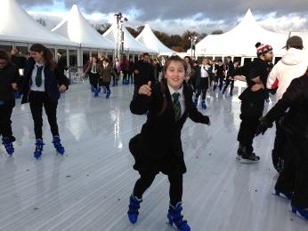
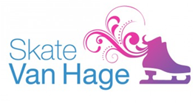
Tuesday, 11 November 2014

Dear Parent \ Carer

Once again we have negotiated a deal with Van Hage so that all of our students can enjoy a subsidised skating session and have a hot chocolate for only £7.00 on Thursday 4th December 2014.

Each year group has been allocated a time slot and will travel to and from Van Hague by Golden Boy coaches.
- Year Seven 11.00am – 12.00pm
- Year Eight 12.00pm – 1.00pm
- Year Nine 1.00pm – 2.00pm
- Year Ten 2.00pm – 3.00pm
- Year Eleven 3.00pm – 4.00pm
- Sixth Form 7.00pm – 8.00pm (students make their own way there and back)

Break and lunch arrangements will be modified accordingly and we have made the day a non-uniform day to make it easier for the students to skate. When your child isn’t skating or travelling, normal lessons will take place. Due to the complexity of organising such an activity day, students who cannot or do not wish to participate will be given appropriate work to do and will be supervised at Chauncy whilst their year group attends the session.

If you would like your son or daughter to participate in this excellent trip, please complete payment via WisePay, (instructions are included with this letter), by Friday 21st November 2014. Please note that payment must be made by this date or we will lose the booking at Van Hage. There is no charge for families who are in receipt of Free School Meals on this trip but they will still have to confirm their child’s attendance on Wisepay.

For any queries concerning payment please contact Jackie Grosch by e-mail: jackie.grosch@chauncy.org.uk or telephone 01920 411200. If you have any general questions about the trip please e-mail me at stephen.walton@chauncy.org.uk or telephone 01920 411200.

Yours faithfully,

Mr S Walton (Deputy Headteacher)

