Textiles: Art and Design Exam board: Eduqas

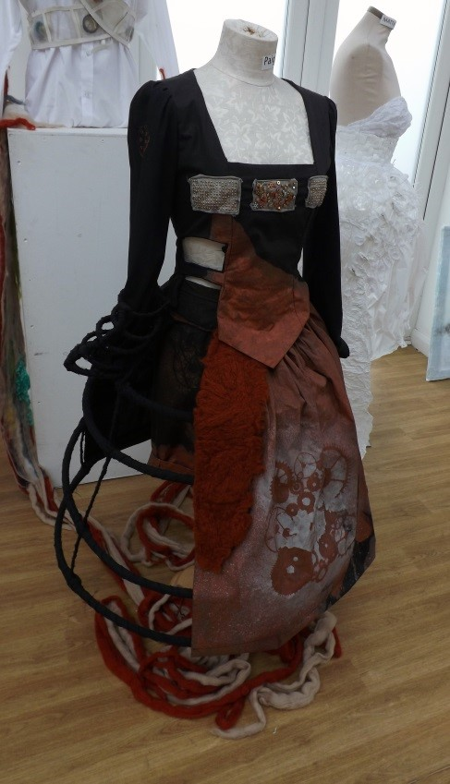
Textile design is a versatile course that involves the manipulation and application of a range of materials and processes in order to produce outcomes for different uses. Textiles students should enjoy experimenting with materials and techniques in order to create unique ideas that can be used for different applications; garments, upholstery, installations and sculpture.

At the core of any textile art and design related practice is drawing. Drawing is an essential skill in the development process of translating ideas into finished designs.

Students should demonstrate a keen interest in the work of other designers and artists, using them as an inspirational starting point for their own development work. Their studies will be supported by contextual visits to various London Galleries where they will use their understanding to inform their own creative journey.

The course culminates in an exhibition of their final outcomes at The Chauncy Gallery during the summer term.
Summary of assessment
Weighting of A Level course  60 % Coursework  40% Exam | Coursework  60% Personal Project and a 1000 word essay | Exam  40% Externally set project  15 hour sustained focus – Final outcome

 | Term | Portfolio |  | Method of assessment
Year 12 | Autumn Term  Component 1  Coursework | Induction Period  Students given opportunities to develop their knowledge, understanding and skills, to include:  - Generating and developing ideas  - Researching primary and contextual sources  - Recording practical and written observations  - Exploring materials, processes, technologies and techniques  Introduction to research skills and analysis of sources | •  •  • | Internally set  Internally marked  Externally moderated
 | Spring term  Component 1  Coursework | Students given further opportunities to develop their knowledge, understanding and skills | •  •  • | Internally set  Internally marked  Externally moderated
 | Summer term  Component 1  Coursework | Students given further opportunities to develop their knowledge, understanding and skills  Students start work on Personal  Investigation | •  •  • | Internally set  Internally marked  Externally moderated
Year 13 | Autumn term  Component 1  Coursework | - Students continue with personal investigation  - Personal study - 1000 word essay. | •  •  • |  | Internally set  Internally marked  Externally moderated
 | Spring term  Component 2  Exam | Externally set assignment  - Preparatory studies – Sketchbook/ Presentation boards.  - 15 hour period of sustained focus – Final outcome. | •  •  • |  | Externally set  Internally marked  Externally moderated
 | Summer term  Component 2  Exam | Students complete the Externally Set  Assignment  Students finish their Personal  Investigation and present work for the exhibition | •  •  • |  | Externally set  Internally marked  Externally moderated
Frequently asked questions
Do I have to have studied Textiles at GCSE?
To be considered for a place on the course you should obtain a 5 grade or above at GCSE. Those students that would like to study A level Textiles, but have not obtained a GCSE 5 grade, will still be considered and interviewed, students will be then expected to attend an ‘Access to A level’ course to build and develop essential skills.
How much written work is involved?
The course does involve some written work in the form of sketchbook annotations. Within the second year of the course there is a personal study essay of 1000 words (min).
Do I need to buy any textile or art materials?
The textile and art department are well equipped with materials that are available to students. However, if specialist materials are required then students may have to source them independently.
Will this course help me to get a place at college or university?
These courses will give you the opportunity to build an experimental portfolio to show case student skills and creative abilities. Work created by the students is then used during the interview process in order to gain a place on degree courses or other higher education qualifications.
Will I get a good grade?
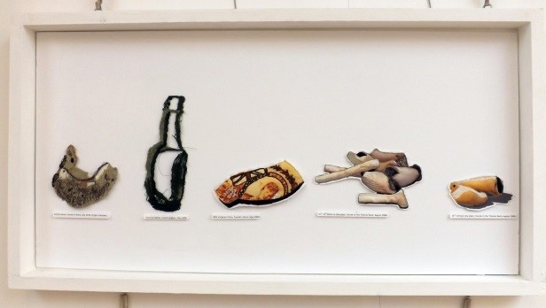
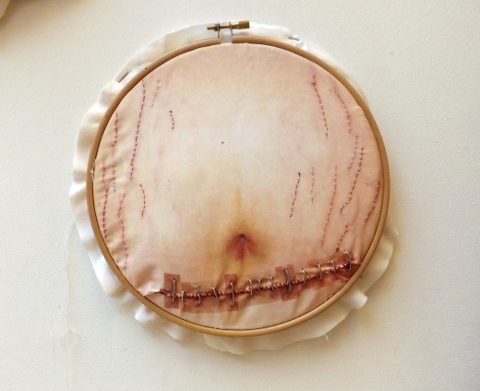
The textiles department is highly supportive of all students, we have high expectations and students work well to achieve their desired result. Students are encouraged to direct their own choice of study in textiles, alongside the syllabus requirements and because of this results are original and exciting. Mrs L Smith, Head of Art

