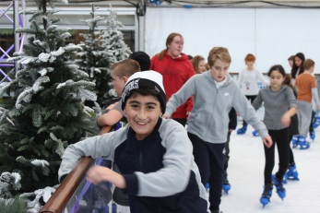
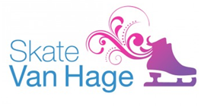
Thursday, 03 November 2016

Dear Parent \ Carer

Once again we have negotiated a deal with Van Hage so that all of our students can enjoy a subsidised skating session for only £7.00 on Wednesday 7th December 2016.

Each year group has been allocated a time slot and will travel to and from Van Hage by coaches or by school minibuses.
- Session 1: 11.00am – 12.00pm
- Session 2: 12..00pm – 1.00pm
- Session 3: 1.00pm – 2.00pm

Break and lunch arrangements will be modified accordingly and we have made the day a non-uniform day to make it easier for the students to skate. When your child isn’t skating or travelling, normal lessons will take place. Due to the complexity of organising such an activity day, students who cannot or do not wish to participate will be given appropriate work to do and will be supervised at Chauncy whilst their year group attends the session.

Van Hage will be making these sessions exclusive to Chauncy School. Therefore we will need to confirm numbers quickly to secure our booking. If your son or daughter wishes to participate in this excellent trip, please complete a payment of £7.00 via WisePay no later than Friday 11th November 2016. A Wisepay instruction letter can be found on the reverse of this letter. Please direct any questions about Wisepay to Jackie Grosch via jackie.grosch@chauncy.org.uk or telephone 01920 411200.

Students who receive Free School Meals do not have to pay for this trip. We will need to know that they would like to go however. Please complete the slip below and return to Chauncy School no later than Friday 11th November 2016.

Each skating session is restricted to 200 skaters so places on this trip will be available on a first come, first served basis. If you have any general questions about the trip please e-mail me at stephen.walton@chauncy.org.uk or telephone 01920 411200.

Yours faithfully,

Mr S Walton (Deputy Headteacher)
- - - - - - - - - - - - - - - - - - - - - - - - - - - - - - - - - - - - - - - - - - - - - - - - - - - - - - - - - - - - - - - - - - - - - - - - - - - - - - - - - - - - - -
VAN HAGE ICE SKATING TRIP – WEDNESDAY 7TH DECEMBER 2016 – FREE SCHOOL MEALS TICKET
PLEASE RETURN NO LATER THAN FRIDAY 11TH NOVEMBER 2016

- My child is entitled to Free School Meals and would like a place on the Van Hage Ice Skating Trip
Name of student: . . . . . . . . . . . . . . . . . . . . . . . . . . . . . . . . . . . . . . Form Class: . . . . . . . . . . . . .
Signature of parent \ carer: . . . . . . . . . . . . . . . . . . . . . . . . . . . . . .
Date: . . . . . . . . . . . . . . . . . . . . . . . . . . . . . . . . . . . . . . . . . . . . . . . .

