Gold Arts Award Enrichment Course
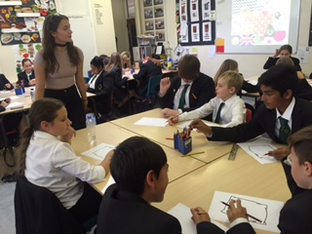
This course is delivered as an enrichment course for students who would like to develop creativity, communication, planning, teamwork and leadership skills. The award is also recognised on the UCAS Tariff (16 points).
Gold has two units – Unit 1: personal arts development and Unit 2: arts projects leadership.
For Gold Unit 1: personal arts development, students extend their knowledge and skills as artists by gaining experience of a new area of the arts. They also explore the professional arts world through placements, volunteering, training and research. They experience and review high quality arts events and form a view on an arts issue that they care about.

For Gold Unit 2: arts project leadership, students take charge of running an arts project, building their skills as an effective leader by identifying the qualities of a leader and the personal leadership skills they want to develop. They take independent responsibility for every aspect of an arts project, from planning stages to delivery and delivering their project to a public audience.
Employers, universities and colleges know that Arts Award is a qualification that shows young people’s level of commitment and progress in the arts, and in developing new skills.
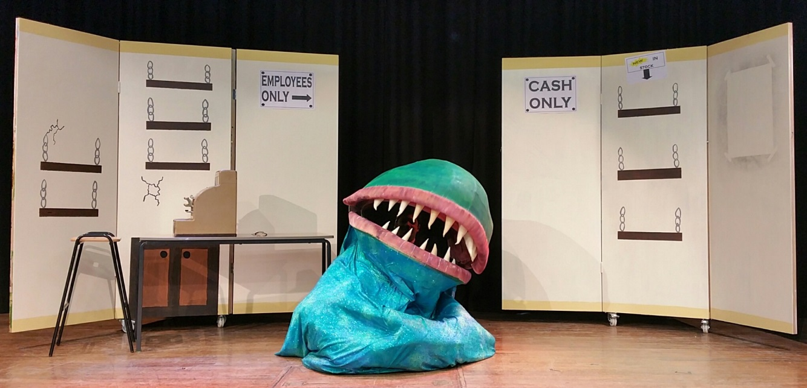
Rebecca Collins, Teacher of Art

